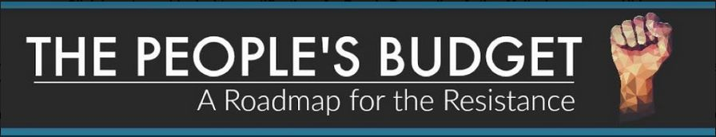
The People’s Budget - Health Care
Not One Penny to billionaire corporations that seek to keep the cost of health care high. The People's Budget does not fund million dollar salaries and bonuses for healthcare and Big Pharma CEOs. This budget allows Health and Human services to negotiate the price of prescription drugs, combats monopolies held by drug companies preventing development of lower cost generic drugs and ends the $19.5 billion corporate subsidy for junk food marketing to children.
Every American has a right to health care. The People’s Budget builds on the gains made through the Affordable Care Act and prioritizes reforms to increase access, equity, and affordability. The People’s Budget protects Medicare's integrity and improves its long-term solvency. It protects children and low-income Americans and gives states the freedom to transition to a single payer system.
Reducing the Cost of Prescription Drugs — Prescription drug costs are too high. We need to prevent drug corporations from setting arbitrary prices just to boost their profits. Our budget permits the Secretary of Health and Human Services (HHS) to negotiate cheaper drug prices with pharmaceutical companies. This will significantly lower the price of prescription drugs for seniors and save Medicare $429 billion. The People’s Budget also combats monopolies held by drug companies and the use of patent settlements to block generic drug competition for a growing number of branded drugs, also known as “pay-for-delay.” Our budget ensures Americans have access to affordable prescription drugs.
Prescription Drug Addiction and Mental Health — More than 50,000 Americans died from drug overdoses last year. Comprehensive mental health and addiction treatment is critical in order to address this horrific epidemic. The People’s Budget increases current mental health funding to support the Substance Abuse and Mental Health Services Administration (SAMHSA), as it continues to implement the 2016 Comprehensive Addiction and Recovery Act. It also expands current efforts at HHS and DOJ to expand drug overdose prevention strategies, including rehabilitation, and improve access to the overdose-reversal drug naloxone. One in five American adults experience a mental health issue at some point in their life, yet millions do not receive the care they need. In order to support access to preventive mental health services, the People’s Budget increases access to psychiatric care, provides funding to increase the behavioral health workforce, and ensures that the mental health systems work for everyone.
Women’s Health — President Trump and Congressional Republicans have made it a priority to defund women’s health care. These cuts will reduce access to services like cancer screenings and put millions of American women and families’ health care at risk. The People’s Budget takes critical steps to strengthen women’s social and economic standing, including allowing women to make decisions about their own health care. It does not include the restrictive Hyde Amendment and it increases Title X funding so that at-risk women and children have
comprehensive access to health services. An investment in women and children is an investment in America’s future.
Extending the Children’s Health Insurance Program (CHIP) — The People’s Budget extends funding for the entire CHIP program until 2019. The CPC Budget also protects state child health programs by fully retaining the maintenance of effort requirements and eliminating any States ability to arbitrarily implement enrollment caps. This secures federal funding for more than 10 million children and pregnant women into the future.
Cigarette Tax — The CPC budget raises the federal excise tax on cigarettes by 50 cents per pack to invest $33 billion into Americans’ health care needs and to discourage smoking. Research shows that every 10 percent increase in the real price of cigarettes reduces overall cigarette consumption by approximately three to five percent.
Junk Food and Fast Food Marketing — The People’s Budget ends $19.5 billion in tax breaks for advertising and marketing junk food and fast food to children. One out of every three children is overweight or obese, disproportionately affecting communities of color and low-income children.
Closing the Medicare Tax Loopholes — The People’s Budget adopts former Rep. Charles Rangel’s (D-NY) Narrowing Exceptions for Withholding Taxes (NEWT) Act, which would clarify that individuals are unable to avoid employment taxes by routing their earnings through a limited liability corporation or a limited partnership. The People's Budget ensures that high-income individuals fully contribute to Medicare.
State Waivers — Until we guarantee universal access to quality care, our work is not complete. The People’s Budget endorses providing states with the ability to set up and administer more efficient state-based single payer health programs. It allows necessary waivers and protects existing federal funding for states that establish single payer programs.
Repeal Excise Tax on High-Price Health Plans and Replace with a Public Option — We improve upon the Affordable Care Act by repealing the excise tax on high-priced health plans. The People’s Budget replaces the 40 percent excise tax with a public option to allow the Secretary of Health and Human Services to offer a public insurance option within the health insurance marketplaces. This ensures choice, competition, and stability in coverage. The Congressional Budget Office (CBO) estimates the premium costs for Americans under the public option will be 7 to 8 percent lower than costs in private exchange plans. The repeal of the excise tax will reduce revenues by approximately $132billion, while savings from the public option are $176 billion.

